Name: Kainaat Rafiq Hussain Makhani
Registration #: 2012296
Semester and Section: 7A
LAB 4

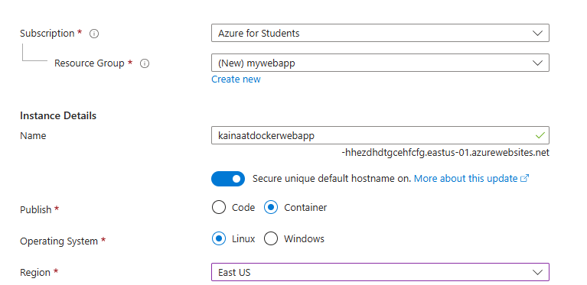

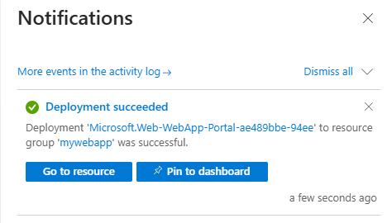

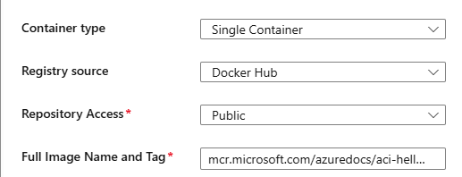

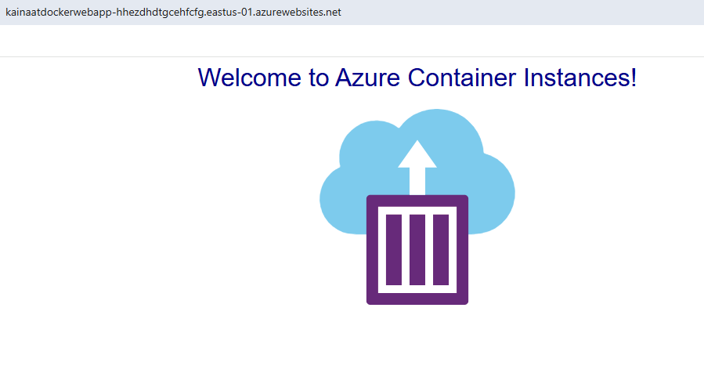

Description:
In this lab, you created a web app using Azure App Service, which runs a Docker container with a simple "Welcome to Azure Container Instances!" message. The process involved signing in to the Azure portal, creating a new Web App with a Docker container, and configuring it to use a public Docker image from Docker Hub. After the web app was deployed, you tested it by accessing the URL and observing telemetry data, such as the number of requests and average response time. Finally, you learned how to delete the resource group to avoid additional costs.

